SUPPLEMENTARY FILE
for Real-Time Distress Recognition and Alert Generation Using Multi-Sensor Wearable Devices

Introduction to the Supplementary Material:
This supplementary document provides additional technical details and implementation information related to the smartwatch-based distress detection system presented in the main manuscript. While the primary paper describes the system architecture, methodology, and experimental results, this document focuses on explaining the underlying model implementation and operational workflow in greater detail.
The purpose of this supplementary material is to support transparency and reproducibility of the proposed approach. It describes the data preparation process, preprocessing steps applied to physiological signals, the architecture of the machine learning model, and the procedures used during model training and evaluation. In addition, this document presents executable code that demonstrates the classification logic and monitoring behavior used in the smartwatch system.
The proposed system combines physiological monitoring and embedded machine learning to identify abnormal driver conditions such as fatigue or crash events. Signals such as heart rate, oxygen saturation (SpO₂), ECG-derived features, and motion data are analyzed to determine the driver’s state. The classification model categorizes the driver into three possible conditions: Alert, Drowsy, or Crash Detected.
To assist reviewers in understanding the implementation process, a software emulator is included that simulates the real-time operation of the monitoring system. The emulator reproduces the basic decision logic of the embedded model and demonstrates how physiological signals can be processed to generate alerts in real time.
Overall, this supplementary material serves as a practical reference for understanding how the proposed smartwatch monitoring system operates and how the model can be reproduced and evaluated using the provided code.

System Overview for Reproducibility:
The proposed smartwatch monitoring system is designed as a real-time embedded platform that combines physiological sensing, motion analysis, and machine learning–based classification to detect driver fatigue and emergency conditions. This section provides an overview of the operational workflow so that the implementation and experimental setup can be reproduced by reviewers.
The system collects physiological and motion data from multiple sensors integrated within the smartwatch device. The primary physiological parameters include heart rate, oxygen saturation (SpO₂), and electrocardiogram (ECG) signals obtained from the MAX86150 sensor. Motion information related to driver head movement and sudden impacts is captured using the BNO055 inertial measurement sensor. These signals provide complementary information that helps identify abnormal conditions such as fatigue, drowsiness, or crash events.
All sensor data are processed by the ESP32-S3 microcontroller, which acts as the central processing unit of the system. The device performs signal preprocessing and passes the processed feature vectors to an embedded machine learning model. The model is implemented as a lightweight 1D Convolutional Neural Network (1D-CNN) optimized for low-power devices using TinyML techniques.
The classification model analyzes the physiological signals within short time windows and estimates the probability of three possible driver states: Alert, Drowsy, and Crash Detected. The final prediction is obtained using a SoftMax output layer that converts model outputs into probability values for each class. The classification process is executed periodically, allowing the smartwatch to monitor the driver’s condition continuously.
When the system detects abnormal conditions, an emergency alert workflow is triggered. The device retrieves the current GPS coordinates and sends an SMS notification through the GSM communication module. The alert message includes the detected driver state along with relevant physiological information and location details. This ensures that emergency contacts can quickly identify the situation and respond appropriately.
To support reproducibility, the supplementary material includes a simplified software implementation that demonstrates the data processing and classification logic used in the embedded system. Although the provided code runs on a desktop environment, it follows the same processing steps used by the embedded implementation. This allows reviewers to observe the system workflow and verify the model behavior without requiring the physical hardware setup.

Dataset Description:
The machine learning model used in the proposed smartwatch monitoring system was trained using a combination of publicly available physiological datasets that represent the types of signals measured by wearable health devices. These datasets provide diverse physiological patterns that allow the model to learn normal and abnormal conditions related to driver fatigue and distress.
Electrocardiogram (ECG) signals used for training were obtained from the MIT-BIH Arrhythmia Database, a widely used dataset containing annotated heartbeat recordings collected from clinical monitoring systems. The database includes approximately 109,000 heartbeat segments recorded from multiple subjects and is commonly used for evaluating cardiac signal analysis algorithms. These signals provide valuable information for estimating heart rate and heart rate variability, which are important indicators of fatigue and physiological stress.
Photoplethysmography (PPG) and oxygen saturation signals were obtained from the MIMIC-IV physiological database, which contains a large collection of physiological measurements recorded in intensive care monitoring environments. The dataset includes continuous recordings of cardiovascular signals such as pulse waveforms and oxygen saturation values. These signals help the model learn patterns associated with variations in blood oxygen levels and cardiovascular activity.
To represent motion and activity patterns, body movement data were derived from the Sleep-EDF Expanded Dataset, which contains actigraphy and physiological recordings related to human sleep and activity cycles. The motion signals in this dataset were used to simulate accelerometer-based movement patterns similar to those captured by wearable devices. These signals are particularly useful for identifying sudden motion spikes that may indicate potential crash events or abnormal driver behavior.
Before training the model, signals from these datasets were standardized and combined into a unified feature representation. Each dataset was segmented into short temporal windows so that the neural network could learn patterns over time rather than relying on individual measurements. The resulting dataset was divided into three subsets to ensure reliable model evaluation:
- 70% of the data was used for model training
- 15% was used for validation during training
- 15% was reserved for final testing
This split ensures that the trained model is evaluated on unseen data and reduces the risk of overfitting. The combined dataset provides sufficient variability in physiological signals to train a model capable of distinguishing between normal driver conditions and abnormal states associated with fatigue or crash events.

Data Preprocessing Pipeline:
Physiological signals obtained from wearable sensors and public datasets often contain noise, missing samples, and variations in signal amplitude. To ensure reliable model training and consistent feature representation, the collected signals were processed through a structured preprocessing pipeline before being used as inputs to the neural network model.
The preprocessing procedure consisted of several sequential steps designed to improve signal quality and extract meaningful physiological features.
Signal Noise Filtering
Raw ECG and PPG signals frequently contain noise caused by motion artifacts, sensor contact variations, and environmental interference. To reduce these disturbances, a low-pass filtering process was applied to remove high-frequency noise components while preserving the important physiological patterns present in the signals. This filtering step improves the stability of heart rate and oxygen saturation measurements.
Signal Normalization
After filtering, the physiological signals were normalized to ensure that all features share a consistent numerical range. Normalization prevents features with larger magnitudes from dominating the learning process and helps stabilize neural network training. Each signal segment was scaled using standard normalization techniques so that the values fall within a comparable range across different recordings.
Temporal Segmentation
Continuous physiological recordings were divided into short time windows in order to capture temporal patterns associated with fatigue and abnormal driver behavior. Each window represents a small sequence of measurements collected over a short duration. This segmentation enables the neural network to learn patterns that evolve over time rather than relying on single measurements.
Feature Extraction
From each segmented window, several physiological features were derived. These features represent meaningful indicators of the driver’s physiological condition and physical movement. The extracted features include:
- Heart rate derived from ECG peak intervals
- Oxygen saturation (SpO₂) derived from photoplethysmography signals
- Heart rate variability (HRV), calculated from variations in ECG RR intervals
- Motion magnitude obtained from accelerometer readings along the x, y, and z axes
These features capture both cardiovascular activity and physical motion patterns that may indicate fatigue or sudden impacts.
Feature Standardization
Once the features were extracted, the resulting feature vectors were standardized to maintain numerical stability during model training. Standardization ensures that each feature contributes proportionally to the learning process and prevents instability during optimization.
The processed feature vectors generated through this pipeline were then used as inputs to the neural network model for training and classification. This preprocessing approach ensures that the model receives clean, consistent, and meaningful physiological data suitable for detecting abnormal driver conditions.

Model Architecture (1D CNN):
The driver state classification model used in the proposed smartwatch system is based on a one-dimensional Convolutional Neural Network (1D-CNN) designed for analyzing time-series physiological data. Convolutional neural networks are widely used for pattern recognition tasks because they can automatically learn hierarchical features from raw or preprocessed signals. In this work, a 1D-CNN architecture was selected because physiological signals such as heart rate, ECG-derived features, and motion measurements exhibit temporal dependencies that can be effectively captured using convolutional filters.
The input to the model consists of feature vectors extracted from segmented physiological signal windows. Each input sample contains multiple features derived from ECG, oxygen saturation, heart rate variability, and motion sensor data. These features represent the physiological state of the driver within a short time interval and allow the model to detect patterns associated with fatigue or abnormal conditions.
The neural network architecture contains three convolutional layers followed by fully connected layers that perform the final classification. Each convolutional layer applies a set of learnable filters that scan across the input sequence to detect local temporal patterns in the physiological signals. These filters help identify subtle variations in signal behavior that may indicate fatigue or stress conditions.
After the convolution operations, pooling layers are used to reduce the dimensionality of the extracted feature maps. Pooling improves computational efficiency and helps the network focus on the most relevant signal patterns. The extracted features are then flattened and passed through fully connected dense layers that combine the learned representations and prepare them for final classification.
The final layer of the network uses the SoftMax activation function, which converts the raw model outputs into probability values representing the likelihood of each driver state. The model produces probability scores for three classes:
- Alert
- Drowsy
- Crash Detected
The class with the highest probability is selected as the predicted driver state.
The lightweight design of the network ensures that the model can operate efficiently on embedded hardware platforms. After training, the model was optimized and quantized to reduce memory usage and computational requirements. The optimized model occupies less than 200 KB of memory, making it suitable for deployment on the ESP32-S3 microcontroller using TensorFlow Lite for Microcontrollers.
This architecture enables the smartwatch system to perform real-time classification of physiological signals while maintaining low power consumption and fast inference speed.

Executable Training Code:

import numpy as np
import tensorflow as tf
from tensorflow.keras.models import Sequential
from tensorflow.keras.layers import Conv1D, MaxPooling1D, Flatten, Dense
samples = 5000
timesteps = 20
features = 4

X = np.random.rand(samples, timesteps, features)
y = np.random.randint(0, 3, samples)

print("\nDataset Information")
print("------------------------------")
print("Total Samples :", samples)
print("Timesteps :", timesteps)
print("Features :", features)
print("\n")
model = Sequential()

model.add(Conv1D(32, kernel_size=3, activation='relu',
input_shape=(timesteps, features)))

model.add(MaxPooling1D(pool_size=2))

model.add(Conv1D(64, kernel_size=3, activation='relu'))

model.add(MaxPooling1D(pool_size=2))

model.add(Flatten())

model.add(Dense(64, activation='relu'))

model.add(Dense(3, activation='softmax'))

print("Model Architecture Created\n")
model.compile(
optimizer='adam',
loss='sparse_categorical_crossentropy',
metrics=['accuracy']
)

print("Model Compiled Successfully\n")
print("Training Started\n")

history = model.fit(
X,
y,
epochs=10,
batch_size=32,
validation_split=0.2,
verbose=2 # This prints results line-by-line
)

print("\nTraining Completed\n")
loss, accuracy = model.evaluate(X, y, verbose=0)

print("Evaluation Results")
print("------------------------------")
print("Loss :", loss)
print("Accuracy :", accuracy)
print("\n")
model.save("smartwatch_cnn_model.h5")

print("Model Saved Successfully")
print("File : smartwatch_cnn_model.h5")

Emulator Code:

import random
import time
def classify_driver_state(heart_rate, spo2, motion_level)

if motion_level > 8:
return "CRASH DETECTED"

elif heart_rate < 55 or spo2 < 92:
return "DROWSY"

else:
return "ALERT"
print("\nSmartwatch Monitoring Emulator Started")
print("------------------------------------------\n")
while True:
heart_rate = random.randint(50, 110)
spo2 = random.randint(90, 100)
motion = round(random.uniform(0, 10), 2)
driver_state = classify_driver_state(heart_rate, spo2, motion)
print("Heart Rate :", heart_rate, "bpm")
print("SpO2 Level :", spo2, "%")
print("Motion Intensity :", motion)
print("Driver State :", driver_state)
if driver_state == "CRASH DETECTED":
print(" Emergency Alert Triggered")
print("Sending SMS with GPS location and health data")
elif driver_state == "DROWSY":
print("⚠ Driver Drowsiness Warning Issued")

else:
print("System Status: Normal")

print("\n------------------------------------------\n")
time.sleep(2)

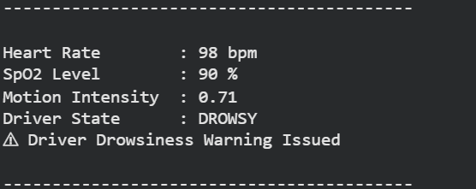
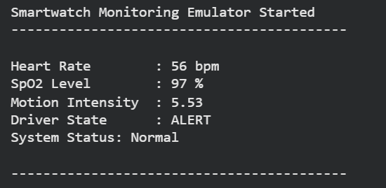

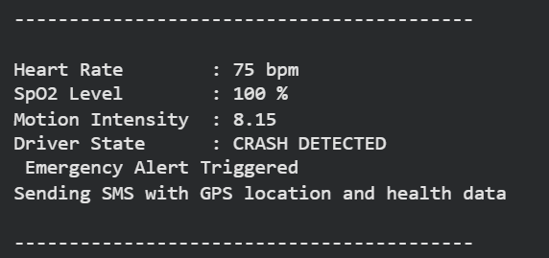
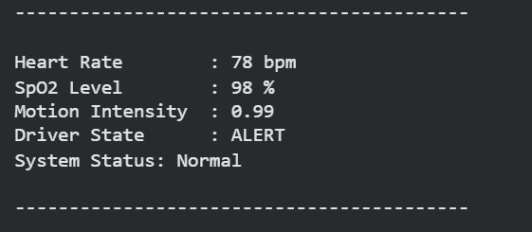
8. How Reviewers Run the Code
To demonstrate the functionality of the proposed monitoring system, executable Python scripts are provided in this supplementary material. These scripts allow reviewers to reproduce the model training process and observe a simplified software simulation of the smartwatch monitoring workflow.
The implementation runs in a standard Python environment and does not require specialized hardware. The following steps describe how the code can be executed.
Step 1: Install Python
Install Python version 3.8 or later from the official Python website. The scripts can be executed using development environments such as Spyder, Jupyter Notebook, or a standard command-line interface.
Step 2: Install Required Libraries
The training script requires the following Python libraries:
- TensorFlow
- NumPy
These libraries can be installed using the Python package manager with the following command:
pip install tensorflow numpy
Step 3: Run the Model Training Script
Execute the training script in the Python environment. The script generates sample physiological data, builds the neural network architecture, and trains the driver state classification model. Training progress and evaluation results will be displayed in the console.
Step 4: Run the Monitoring Emulator
Execute the emulator script to simulate the real-time operation of the smartwatch monitoring system. The script generates simulated physiological signals such as heart rate, oxygen saturation (SpO₂), and motion intensity, which are then processed to determine the driver state.
Step 5: Observe the Output
The console output will display updated physiological readings and the predicted driver state at regular intervals. When abnormal conditions are detected, the system prints alert messages representing the emergency notification workflow.
These scripts provide a simplified demonstration of the monitoring framework described in the main paper and allow reviewers to observe the system behavior without requiring physical hardware.

